Hello,

Thanks for helping me with this project. The aim is to develop a macropad that couples a standard set of 4x4 keys with a smartknob/high resolution rotary encoder that is essentially a BLDC motor coupled with a magnetic rotary encoder/rotation sensor.

The BLDC motor is driven by an ESP32 coupled to a TMC6300 (breakout board). The motor is only used for mild haptic feedback so the current required can be provided by a modern USB port, though more than 500 mA of current is required. The magnetic sensor is a MT6701.

The ESP32 is then connected to an Arduino Pro Micro (running QMK) via serial. The macropad is directly connected to the Pro Micro. I’m still tweaking the serial transmission a bit, so mode change is now handled by direct GPIO.

I have the diagram of the 4x4 macropad all set out, but the smartknob part has been stumping me for a while.

As discussed, the main issue is that powering the board through the Pro Micro doesn’t deliver enough current to the rest of the circuit, hence I would like to embed everything onto the board and substitute a more robust power delivery circuit.

I would like the connection point to be a Type C socket that is directly connected to the “Pro Micro”/ATmega as this is running QMK.

# ESP32

Pinout:

* Driving the motor
  + DPIN_UH=26
  + DPIN_UL=25
  + DPIN_VH=27
  + DPIN_VL=32
  + DPIN_WH=12
  + DPIN_WL=33
* “Next Mode” direct GPIO
  + DPIN_BUTTON_NEXT=22
* SSI connection to the MT6701
  + DPIN_MT_DATA=19
  + DPIN_MT_CLOCK=18
  + DPIN_MT_CSN=5
* Serial communication with Pro Micro
  + DPIN_SERIAL_TX=22
  + DPIN_SERIAL_RX=23

If you will be embedding this in the board, I would like to use a USB to CH340 programmer for future firmware updates. I am also hoping to retain the EN and BOOT buttons for manual reset if necessary, as I will still be fine tuning the firmware.

# Pro Micro

Pinout:

* D0/1 are used for Rx/Tx respectively
* D8 is used for the mode changing (for now)
* D21/20/19/18/15/14/16/10 are used for the macropad (rows/cols)

I would like to retain 2 test points/jumper points as a reset button.

# Components

* So far I’m using 0603 SMD components as I’m hand soldering
* Size of the final knob will be 5 cm diameter
* MT6701 datasheet:
  + <http://www.magntek.com.cn/upload/MT6701_Rev.1.0.pdf>
* TMC6300-BOB:
  + <https://www.trinamic.com/support/eval-kits/details/tmc6300-bob/>
* Motor:
  + 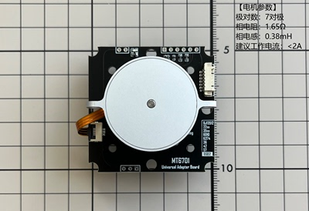 (removed from the board of course)
  + Connection is via FPC, it’s a 6 pin, 0.5 mm spacing that merges into 3 channels (U/V/W)
  + Mounting is via 3 M2 screws positioned 12 mm from the centre point